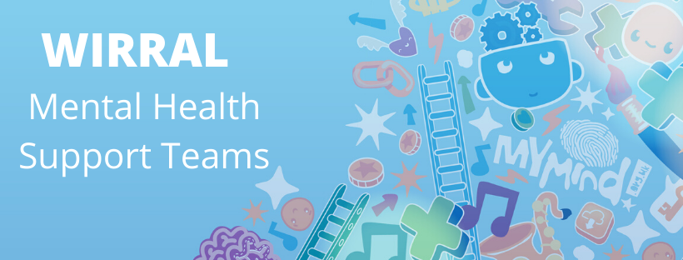
Newsletter 49

An update from your local team
During all school holidays MHST services remain available,from local children's centres on the Wirral.
Due to this we are open to referrals from Primary Schools for the summer break and so please discuss this in your consultations with your school's link worker.
Referrals can also be made using the MyMind website, MyMind Referral Form

Place2Be: Parenting Smart: Articles
Parenting Smart offers practical advice for parents and carers of children aged 5-11. All of their content is created by Place2Be's parenting experts. It's based on evidence and their experiences working with children, young people and their families.
Offering practical advice on supporting their child and managing behaviour. It has short videos and articles on a range of topics.
www.parentingsmart.org.uk

School Grants for Senior Mental Health Leads
The Department for Education has announced new funding for schools to support costs of training for Senior Mental Health Leads in England. Grants of £1,200 are available now to eligible schools.
More details about how to apply for the funding and to reserve your space on the Anna Freud Centre training below.

Men’s Health Week 2022

Men’s Mental Health Week (13-19 June) is an annual event aimed at improving men’s psychological well-being by raising awareness and decreasing stigma while highlighting the unique mental health services and how to access support.

This week focuses on specific men’s health conditions and data suggests that men are less likely to seek help, especially when it comes to mental well-being.

MyMind website and social media

For more information about your local CAMHS service and access to a range of other resources about mental health please click on this link mymind.org.uk

