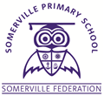
YEAR 6
THE SOMERVILLE PASSPORT

Adventurous residential
Teach younger children a new skill
Make a book for FS2 children for Christmas
Raise money for charity
Plan organise event such as a summer fair
Skim a stone
Enterprise – make money
Keep a diary
Go to the theatre to watch a performance of a famous show.
Go hiking – trek to Moel Fammau

