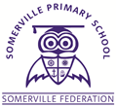
YEAR 3
THE SOMERVILLE PASSPORT

Plant it, grow it, eat it
Learn to swim
Make a daisy chain
Learn yoga and meditation
Visit Chester and pretend to be a Roman soldier,
Make a film
Go foraging for food
Go orienteering in the federation grounds
Watch a concert
Learn to play the recorder
Learn to sew
Visit a new place of worship from another culture

