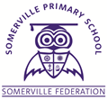
YEAR 2
THE SOMERVILLE PASSPORT

Play a board game
Learn a poem
Go to the zoo
See an orchestra play live in the Philharmonic hall.
Start a vegetable patch and tend throughout the year.
Go pond dipping
Go on the ferry or train.

Play rounders in the park.
Read a story to nursery children.
Make a pizza, cook it and eat it.
Go on a residential for one night
Eat exotic fruit from around the world
Make paper aeroplanes

