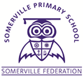
FOUNDATION 2
THE SOMERVILLE PASSPORT

Perform a rhyme
Write and post a letter
Grow a plant
Grow a vegetable
Taste something different
Visit a farm
Have a teddy bears picnic.
Dress up as a super hero
Hold a minibeast
Make a pancake
Go to a campfire
Collect leaves and make leafimals.
Make a salt dough Christmas decoration
Visit Santa Claus

