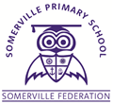
YEAR 1
THE SOMERVILLE PASSPORT

Build a den
Cook on a campfire
Make a map
Pooh stick race
Experience every season
Make and fly a kite
Go to a pantomime
Dress up as a pirate
Take a trip to the seaside and Build sandcastles
Build with lego
Visit a castle
Go on a bug hunt
Experience virtual reality

