PE Funding

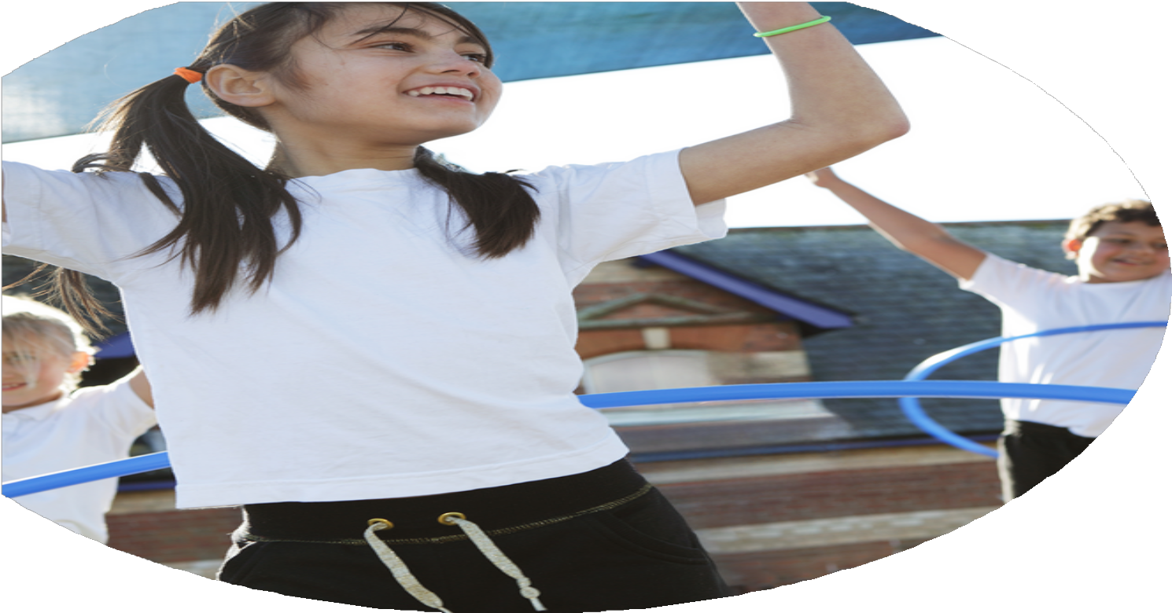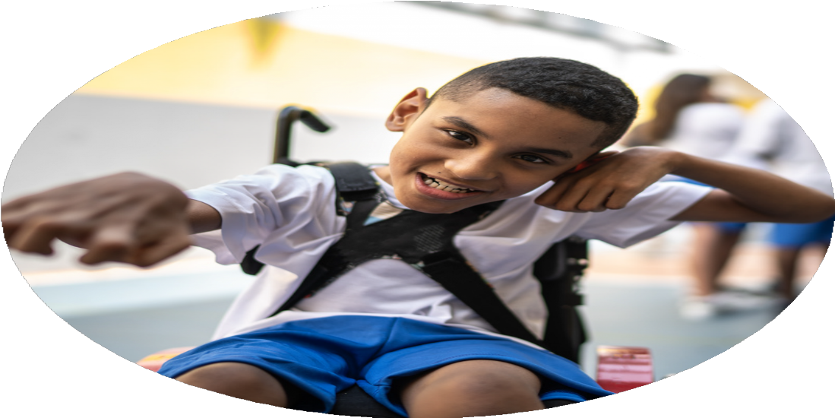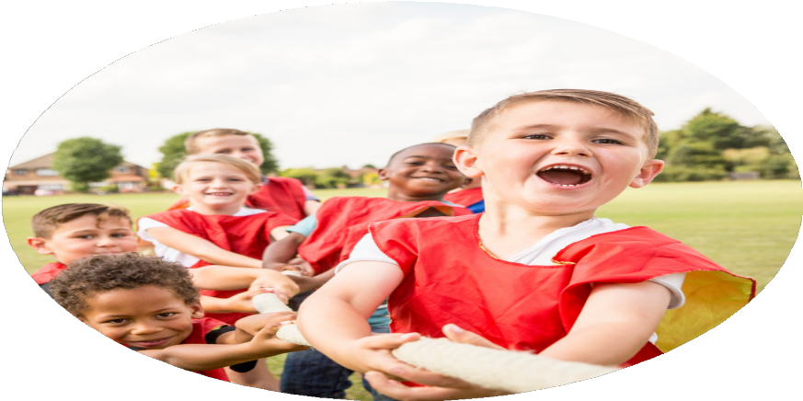

Evaluation Form

**Commissioned by**

**Created by**

Images courtesy of Youth Sport Trust

**PE Funding Evaluation Form**

 It is intended that this template should be used as preparation for the completion of the statutory digital reporting tool being introduced this academic year. You can upload data (including swimming) from this template onto this platform once it becomes accessible.

 Before you decide how you are going to use the funding for this academic year you should reflect and evaluate the impact of your use of the funding in 2023/24.

 All spending of the funding must conform with the terms outlined in the Conditions of Grant document.  The template is a working document that you can amend/update during the year.

 Based on your evaluation of last year’s funding you should decide what you intend to do this academic year, how you will do it, and what impact you expect it to have.

It is important that the funding is used effectively and based on your school’s needs.

 You must use the funding to make additional and sustainable improvements to the PE and sport in your school.  You must develop and add to the PESSPA activities that your school already offers.

*Summative digital reporting from June 2025 will continue to include swimming and water safety information therefore funding can be used to provide top-up lessons where necessary to ensure pupils meet national curriculum swimming requirements.*

|  |  |  |
| --- | --- | --- |
| **What are your plans for 2024/25?**  **Intent** | **How are you going to action and achieve these plans?**  **Implementation** | **Costings for each intent/ action** |
| **Increased knowledge and confidence of all staff, leading to high-quality curriculum PE lessons.** | * Total PE+ Subscription * Edsential Subject Leader Support Programme – Termly meeting with local advisor to support PE Subject Leader in their role. | Included as part of Premium SLA (£350)  Included as part of Premium SLA (£910) |
| **To increase physical activity levels to ensure children are meeting the active 30 minutes within school.** | * Extra-curricular clubs delivered each half term through Edsential. These will be tailored to target different groups of children across the year and ensure we are offering a broad range of extra-curricular activities for children to access. * Edsential PlayMaker Award – Training for up to 15 children from Year 5/6 to lead activities for EYFS and Key Stage 1 at lunchtimes. * Considerable investment in resources for a range of activities for lunchtimes | 3 x afterschool clubs included as part of Premium SLA (3 x £395)  Included as part of Premium SLA (£930)  £5300 |
| **To use physical activity to support mental wellbeing.** | * Edsential Personal Best Programme (1 x 6-week programme delivered throughout the year to target different year groups / children). * Edsential Rainbow Programme (1 x 6-week programme delivered throughout the year to target different year groups / children) | 1 x included as part of Premium SLA (£1,150)  1 x included as part of Premium SLA (£1,150) |
| **To use school sport to develop social skills and promote physical activity outside of school.** | * Competitions and Events, including Edsential Competitions for All Programme * Access to Wirral School Games competitions and events | Included as part of Premium SLA (£425)  Wirral School Games – No cost to access. |
| **To promote ‘Healthy Lifestyles’ through PE, sport and physical activity.** | * Edsential Fitness and Nutrition Workshops (x2) | Included as part of Premium SLA (£550) |
| **To support the development of physical literacy and gross motor skills within EYFS and Key Stage 1.** | * Edsential Fundamentals Programme – Gross-motor skills intervention programme. | 1 x included as part of Premium SLA (£1,150) |

**Intended actions for 2024/25**

**Expected impact/sustainability and supporting evidence**

|  |  |  |
| --- | --- | --- |
| **Intent / Action** | **What impact/intended impact/sustainability are you expecting?** | **How will you know? What evidence do you have or expect to have?** |
| **Increased knowledge and confidence of all staff, leading to high-quality curriculum PE lessons.**   * Total PE+ Subscription * Edsential Subject Leader Support Programme | **Proposed Impact:**   * Lesson observations will show pupils receive Quality First Teaching across the whole PE curriculum - supported through our Total PE+ subscription, including making links to wider curriculum and supporting social development. * Curriculum PE assessments will show an increased number of children working at age-related expectations for PE.   **How sustainability will be achieved:**   * Staff will be confident and competent teaching a range of curriculum areas. These in turn can be used to support our school in the future e.g. staff leading extra-curricular clubs. | **How will impact be measured:**   * Staff Voice across the year will show a growing confidence with the teaching of PE. * Pupil Voice * Curriculum PE attainment data. |
| **To increase physical activity levels to ensure children are meeting the active 30 minutes within school.**   * Extra-curricular clubs delivered throughout the year. * Edsential PlayMaker Award | **Proposed Impact:**   * More pupils will be meeting their daily physical activity goal (30 minutes within school hours) compared to 2023/24. * More pupils taking part in PE and Sport Activities outside of school hours compared to 2023/24. * Increased number of children participating in breakfast and afterschool clubs.   **How sustainability will be achieved:**   * Children will continue their participation within sports outside of school hours. * Participation within clubs will contribute to children increasing physical competence. * Year 5 Play Leaders will continue again in 2025/25 when they are in Year 6. | **How will impact be measured:**   * Club registers and tracking documents * Class discussions and pupil voice * Curriculum PE assessment data (physical skills) * Edsential Impact Report for PlayMaker Award. |
| **To use physical activity to support mental wellbeing.**   * Edsential Personal Best Programme * Edsential Rainbow Programme | **Proposed Impact:**  Pupils will report an increase in one or more of the key outcomes of the programmes:   * Resilience * Self-esteem * Attitudes towards physical activity * Positive mental wellbeing   **How sustainability will be achieved:**   * Personal Best programme and Rainbow Programme outcomes will be transferred into the wider curriculum e.g. pupils showing a developing resilience in a range of curriculum areas, not just PE and sport related. | **How will impact be measured:**   * Edsential Impact Reports for Personal Best. * Staff Voice * Pupil Voice |
| **To use school sport to develop social skills and promote physical activity outside of school.**   * Competitions and Events, including Edsential Competitions for All Programme | **Proposed Impact:**   * Participation within competitive sport will support children to further develop teamwork skills, social and communication skills and supported wellbeing through a sense of ‘togetherness’. * Increased number of children participating regularly within a sports club/ team as a result of our competitions provision across the year. * Children will develop a love of a sport and the confidence to strive to achieve their best- leading onto more areas of school and personal life.   **How sustainability will be achieved:**   * Participation within competitions will lead to an increase in the number of children participating within sports outside of school hours. | **How will impact be measured:**   * Edsential Impact Report for Competitions. * Registers and participation tracking documents. * Pupil Voice |
| **To promote ‘Healthy Lifestyles’ through PE, sport and physical activity.**   * Edsential Fitness and Nutrition Workshops (x2) | **Proposed Impact:**   * Children will develop a deeper understanding of healthy lifestyles, especially around how important the role of sleep is to health and wellbeing. | **How will impact be measured:**   * Pupil Voice |
| **To support the development of physical literacy and gross motor skills within EYFS and Key Stage 1.**   * Edsential Fundamentals Programme | **Proposed Impact:**   * Increased number of children participating in breakfast and afterschool clubs. * Greater number of children showing a good level of physical competence. * Increased numbers of children meeting Physical Early Learning Goals.   **How sustainability will be achieved:**   * Children will continue their participation within sports outside of school hours. * Increase of confidence with own physical ability will lead to participation in more PE / Sport. * Participation within clubs will contribute to children increasing physical competence. | **How will impact be measured:**   * Class discussions and pupil voice * Curriculum PE assessment data (physical skills) * Assessment of Physical ELGs. * Edsential Impact Report for Fundamentals Programme. * Club registers and tracking documents |

**Actual impact/sustainability and supporting evidence**

|  |  |  |
| --- | --- | --- |
| **Intent / Action** | **What impact/sustainability have you seen?** | **What evidence do you have?** |
| **Increased knowledge and confidence of all staff, leading to high-quality curriculum PE lessons.**   * Total PE+ Subscription * Edsential Subject Leader Support Programme | **Impact:**   * Lesson observations show pupils receive Quality First Teaching across the whole PE curriculum - supported through our Total PE+ subscription, including making links to wider curriculum and supporting social development. * PE Subject Leader has received 6 hours of CPD, plus on-going support across the year and access to PE CPD events, including Subject Leader Support Network sessions.   **How sustainability has been achieved:**   * CPD will have a lasting impact upon teaching and learning. Staff will take forward with them the knowledge and skills they have developed this year. * Staff are now more confident and competent teaching a range of curriculum areas. These in turn can be used to support our school in the future e.g. staff leading extra-curricular clubs. | **Evidence:**  All lesson observation videos show high quality teaching and modeling.  80% of the children in the school are achieving the expected standard in PE this is up from 73% for the previous year.  **Staff Voice:**   * 75% of staff reported an increase in confidence teaching PE through using Total PE+ to support teaching and learning.   End of year staff voice shows:   * **Greater confidence in teachers in PE in general.** * **Greater confidence in teachers supporting SEN.** * **More teachers feel confident with a range of resources in gymnastics** |
| **To increase physical activity levels to ensure children are meeting the active 30 minutes within school.**   * Extra-curricular clubs delivered each half term. * PlayMaker Award delivered to train 15 children from Year 5/6 to enhance lunch time provision | **Impact:**   * More pupils are meeting their daily physical activity goal (30 minutes within school hours) compared to 2023/24. * There are an increased number of children participating in breakfast and afterschool clubs.   **How sustainability has been achieved:**   * Pupils will take the learning and skills from extra-curricular clubs into curriculum PE lessons. | **Evidence:**  **Extra-Curricular Clubs:**   * Total number of clubs ran across the year: 29 * 50% of children across the whole school * 52% of KS2 * 45% of KS1 * 15% of EYFS   *Compared to 23/24:*   * Total number of clubs ran across the year: 28 * 52% of children across the whole school * 55% of KS2 * 35% of KS1 * 20% of EYFS   **Lunchtime Activities:**  % of pupil engaged in structured activity at lunch times:   * EYFS = 35% * Key Stage 1 = 41% * Key Stage 2 = 70%   *(Taken as an average across half-termly observations)* |
| **To use physical activity to support mental wellbeing.**   * Edsential Personal Best Programme * Edsential Rainbow Programme | **Impact:**  Pupils reported an increase in one or more of the key outcomes of the programmes:   * Resilience * Self-esteem * Attitudes towards physical activity * Positive mental wellbeing   You can see full details of this within the evidence section.  **How sustainability has been achieved:**   * Children will be able to take the skills and strategies learned and apply them into the wider curriculum. * Children will be more confident to take part in further PE and sport activities, which in turn will lead to greater progress. | **Evidence:**  **Personal Best Programme:**   * [Read our Impact Report here.](https://sway.cloud.microsoft/MR9rtEAqJ4YR9VuM?ref=Link)   **Summary of Spring Term Personal Best Programme Impact:**   * 23% increase in the number of children who reported they ‘can always keep trying when things are difficult’. * 30% increase in the number of children reporting they ‘always feel confident’. * 44% increase in the number of children reporting they ‘always like taking part in PE, sport or physical activity’.   Pupil Voice - Quotes from children who took part in the programme:   * I'm finding that I'm feeling less stressed about things (in and out of school). * I used to struggle with communicating with others but now I find it easier. * I never worked very well in a team, but I do now. * I've really enjoyed all of the encouragement we've been giving each other. * I'm less likely to give up.   **Rainbow Programme:**   * Read our Impact Report here. [*https://sway.cloud.microsoft/7BckH2mxltzbSNuv?ref=email*](https://sway.cloud.microsoft/7BckH2mxltzbSNuv?ref=email) |
| **To use school sport to develop social skills and promote physical activity outside of school.**   * Competitions and Events, including Edsential Competitions for All Programme | **Impact:**   * Participation within competitive sport has supported children to further develop teamwork skills, social and communication skills and supported wellbeing through a sense of ‘togetherness’. * Increased number of children participating regularly within a sports club/ team as a result of our competitions provision across the year. * Children have developed a love of a sport and the confidence to strive to achieve their best- leading onto more areas of school and personal life.   **How sustainability has been achieved:**   * Children will be able to take the skills and strategies learned into the wider curriculum. | **Evidence:**  Number of sporting events entered:   * 2024 – 25 - 12 * 2023 – 24 - 23   % of children who took part in a sporting competition or event during 2024-25:   * EYFS – 82% * KS1 – 92% * KS2 – 91%   Compared to 2023/24:   * EYFS – 0% * KS1 – 25% * KS2 – 41% |
| **To promote ‘Healthy Lifestyles’ through PE, sport and physical activity.**   * Edsential Fitness and Nutrition Workshops (x2) | **Impact:**   * Children have shown a deeper understanding of healthy lifestyles, especially around how important the role of sleep is to health and wellbeing. | **Evidence:**  Pupil Voice following the Fitness and Nutrition workshops:   * 73% of children ‘enjoyed the session’ * 71% of children felt ‘they had a better understanding of how important sleep is to their health’ after taking part. |
| **To support the development of physical literacy and gross motor skills within EYFS and Key Stage 1.**  Edsential Fundamentals Programme | **Impact:**   * Increased opportunities for EYFS children to be physically active. * Greater number of children showing a good level of physical competence based on number of children within Key Stage 1, shown through PE assessments. * Increased numbers of children meeting Physical Early Learning Goals.   **How sustainability will be achieved:**   * Children are continuing their participation within sports outside of school hours. * Increase of confidence with own physical ability will lead to participation in more PE / Sport. * Participation within clubs has contributed to children increasing physical competence. | **Evidence:**  Curriculum PE assessment data (physical skills) shows:   * 90% of children working at ARE for physical skills in Key Stage 1   Assessment of Physical ELGs.   * 85% of all EYFS children meeting physical ELG   Edsential Fundamentals Programme Impact:   * [View our Impact Report here.](https://sway.cloud.microsoft/hFXlWJJSSpQyRFGO?ref=Link&loc=mysways) |

*Meeting National Curriculum requirements for swimming and water safety.*

*Priority should always be given to ensuring that pupils can perform safe self-rescue even if they do not fully meet the first two requirements of the National Curriculum programme of study*

|  |  |  |
| --- | --- | --- |
| **Question** | **Stats:** | **Further context - Relative to local challenges** |
| What percentage of your current Year 6 cohort can swim competently, confidently and proficiently over a distance of at least 25 metres? | 59% |  |
| What percentage of your current Year 6 cohort can use a range of strokes effectively [for example, front crawl, backstroke, and breaststroke]? | 56% |  |
| What percentage of your current Year 6 cohort are able to perform safe self-rescue in different water-based situations? | 49% |  |
| **% of Year 6 children meeting National Curriculum standard for swimming.** | **43%** | **High percentage of holidays booked at the point in the year that y6 go swimming. 2 weeks were booked to attempt to mitigate this however there were still a large percentage away.** |
| If your schools swimming data is below national expectation, you can choose to use the Primary PE and sport premium to provide additional top-up sessions for those pupils that did not meet National Curriculum  requirements after the completion of core lessons. Have you done this? | Yes / ~~No~~ |  |
| Have you provided CPD to improve the knowledge and confidence of staff to be able to teach swimming and water safety? | No | All staff that attended swimming this year have been trained in swimming. |