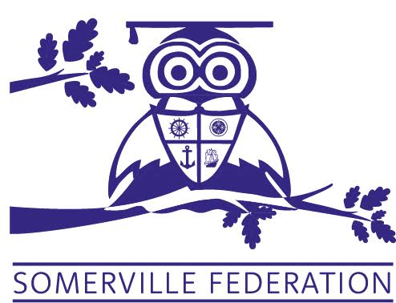

SOMERVILLE FEDERATION SCHEDULE OF CHARGES

Somerville Federation purchase milk for F2 children only and any child under 5 the milk money for those children is claimed back through NMRU the nursery school purchase all milk provision for the whole nursery and claims back using the same procedure

School meal payments are made via Parentpay, at a cost of £2.30 per meal.

Otis Owl Club charge parents and carers £8 per after school session and £2 per breakfast club session. All places are booked and paid for in advance via IPal.

Somerville Nursery parents may pay for additional sessions beyond a Government Funded Nursery Education place at a cost of £22.50 per session from September 2024. These are limited due to the Nursery School offering 30 hours funding places as a priority.
Please see Nursery Policy

