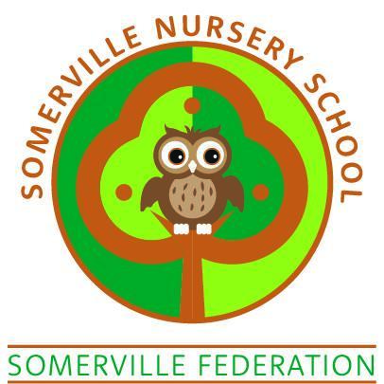

**CHARGING POLICY**

**LUNCH SESSIONS**

**SOMERVILLE NURSERY SCHOOL CHARGING POLICY**

**PAID LUNCH SESSIONS TERMS AND CONDITIONS**

1. A lunch session consists of 30 minutes from 12.00pm to 12.30pm and is available Monday to Friday during term time.
2. The cost per session is £2.50 and does NOT include a school lunch. If your child stays for this session please ensure they bring a packed lunch with them, clearly labelled with their name.
3. Payment is required on a weekly basis in advance every Monday.
4. Payment can be made up to 1 month in advance.
5. Payment can be made via Arbor.
6. If payments fall into arrears the place will be suspended until the full arrears are settled.
7. There is no facility to offer credit.
8. There are a limited number of places available per lunch session.
9. Changes must be notified at least one week in advance so that appropriate staffing is in place and so that staff can plan for the children.
10. If a child is absent for any reason, payment must still be made for missed sessions.
11. Somerville Nursery School reserves the right to terminate the contract immediately if fees are outstanding for fourteen days or more.
12. Children must be collected from their child’s class promptly.
13. The governing body reserves the right to amend the fees and conditions, where appropriate. The decision of Somerville Nursery School remains final at all times.
14. Parents/carers will be given at least one month's notice of fee increases.
15. This contract may be terminated by not less than two weeks notice from either party.
16. A child will only be released into the care of his/her parents/carers. If any other person is collecting your child they must be on your child’s pick up form. The school reserves the right to ask for photographic ID and can only let the child go with a suitable adult over the age of 16 years
17. It is the parent/carer's responsibility to inform the nursery staff of any changes to personal details, address, and telephone numbers in the case of emergencies.

I have read and fully understood these terms and conditions.

Signed Parent A …………………………….Name…………………………….

Parent B ……………..………………Name…………………………….

Child’s Name …………………………….……Date ……………………………..