PE Funding

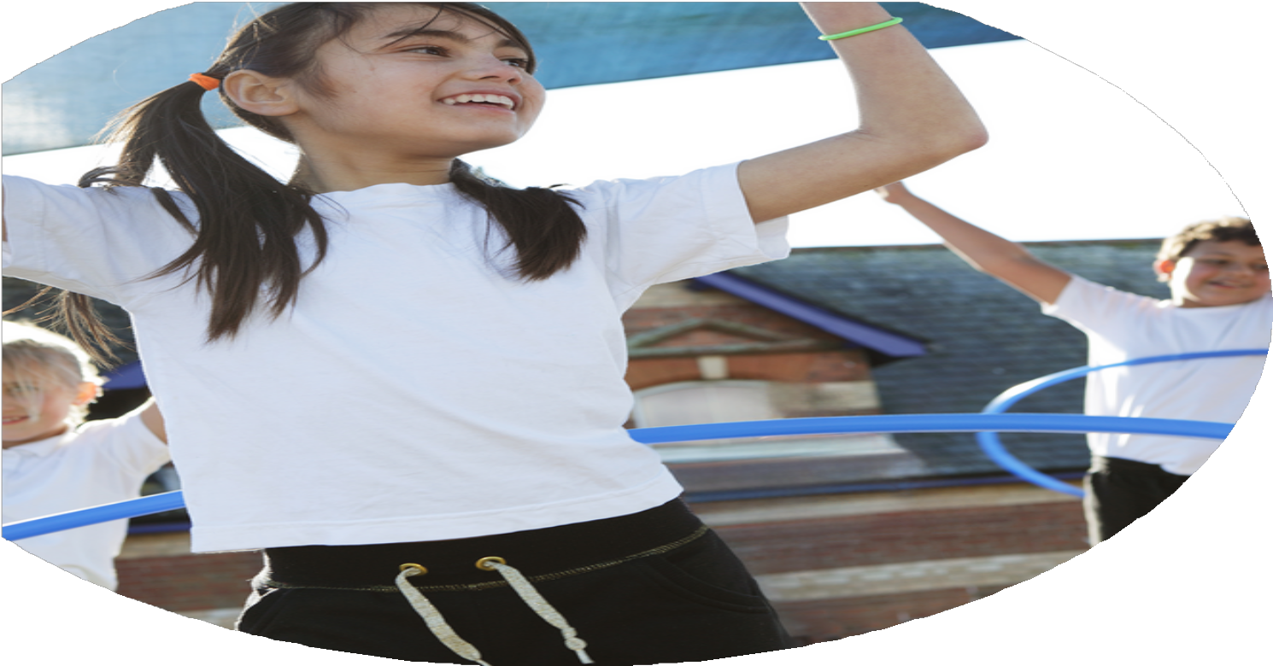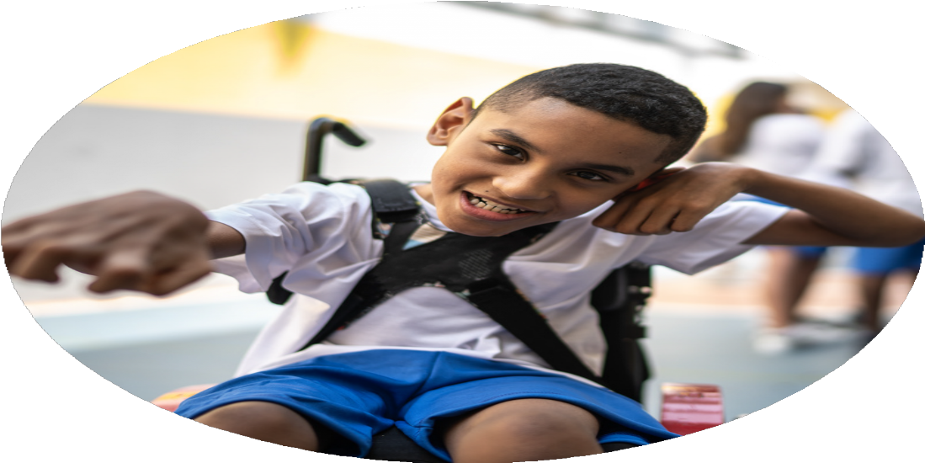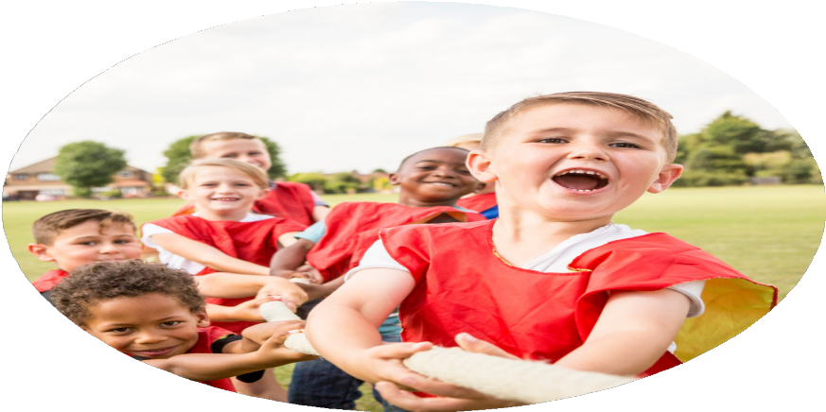

Evaluation Form

**Commissioned by**

**Created by**

Images courtesy of Youth Sport Trust

**PE Funding Evaluation Form**

 It is intended that this template should be used as preparation for the completion of the statutory digital reporting tool being introduced this academic year. You can upload data (including swimming) from this template onto this platform once it becomes accessible.

 Before you decide how you are going to use the funding for this academic year you should reflect and evaluate the impact of your use of the funding in 2023/24.

 All spending of the funding must conform with the terms outlined in the Conditions of Grant document.  The template is a working document that you can amend/update during the year.

 Based on your evaluation of last year’s funding you should decide what you intend to do this academic year, how you will do it, and what impact you expect it to have.

It is important that the funding is used effectively and based on your school’s needs.

 You must use the funding to make additional and sustainable improvements to the PE and sport in your school.  You must develop and add to the PESSPA activities that your school already offers.

*Summative digital reporting from June 2025 will continue to include swimming and water safety information therefore funding can be used to provide top-up lessons where necessary to ensure pupils meet national curriculum swimming requirements.*

|  |  |  |  |  |  |  |  |  |
| --- | --- | --- | --- | --- | --- | --- | --- | --- |
| **End of Year 2023-24 School Data** | F2 | Yr1 | Yr2 | Yr3 | Yr4 | Yr5 | Yr6 | Whole School |
| Percentage expected - all | 88% | 81% | 78% | 72% | 60% | 77% | 78% | 72% |
| Percentage expected - boys | 89% | 82% | 77% | 73% | 61% | 74% | 73% | 73% |
| Percentage expected - girls | 87% | 80% | 78% | 70% | 59% | 73% | 68% | 72% |
| Percentage expected PP | 76% | 65% | 74% | 66% | 54% | 70% | 66% | 66% |
| Percentage expected Non PP | 97% | 91% | 81% | 81% | 67% | 84% | 78% | 79% |
| Percentage expected SEND | 29% | 67% | 56% | 20% | 50% | 60% | 29% | 43% |
| Percentage Non SEND | 98% | 85% | 84% | 84% | 63% | 82% | 82% | 79% |

**Review of last year 2023/24 Som,erville**

**Review of last year 2023/24 Som,erville**

|  |  |  |  |
| --- | --- | --- | --- |
| **What went well?** | **How do you know?** | **What did not go well?** | **How do you know?** |
| Whole school PE data shows that confidence in PE is high with very little disparity between Boy/Girl and pupil prem vs non pupil prem. | Teacher assessment data and regular monitoring over the whole school year. | School SEN data still shows lower SEN achievement – despite a spend on teacher training sessions using Edsential. (£7400 for whole school package) | Teacher assessment data and regular monitoring over the whole school year. |
| Despite SEN data showing disparity against the rest of the school, this was up from 38% on the previous year. | However teacher confidence from exit interviews from Teacher Support sessions showed that teaching SEN pupils was an area teachers are now confident in. | School Swimming provision end of year data – see bottom of report- lower than expected compared to the previous year. | Swimming assessment data - Edsential |
| Engagement of Key Stage 2 children in Sporting events and competitions.  Afterschool Club attendance. | 52% of Key Stage 2 children have taken part in a sporting competition or event.  Good numbers of children from  KS2 attending clubs (42% of all  children).  Year 6 represented Somerville for Liverpool FC |  |  |

|  |  |  |
| --- | --- | --- |
| **What are your plans for 2024/25?**  **Intent** | **How are you going to action and achieve these plans?**  **Implementation** | **Costings for each intent/ action** |
| **Increased knowledge and confidence of all staff, leading to high-quality curriculum PE lessons.** | Total PE+ Subscription  Edsential Subject Leader Support Programme – Termly meeting with local advisor to support PE Subject Leader in their role. | Included as part of Premium SLA (£7,800)  Included as part of Premium SLA (£7,800) |
| **To increase physical activity levels to ensure children are meeting the active 30 minutes within school.** | Extra-curricular clubs delivered each half term through Edsential. These will be tailored to target different groups of children across the year and ensure we are offering a broad range of extra-curricular activities for children to access. (Autumn 2)  Edsential PlayMaker Award – Training for up to 15 children from Year 5/6 to lead activities for EYFS and Key Stage 1 at lunchtimes. | 3 x afterschool clubs included as part of Premium SLA (£7,800)  Included as part of Premium SLA (£7,800) |
| **To use physical activity to support mental wellbeing.** | Edsential Personal Best Programme (1 x 6-week programmes delivered throughout the year to target different year groups / children). (Autumn 2) | Included as part of Premium SLA (£7,800) |
| **To use school sport to develop social skills and promote physical activity outside of school.** | Competitions and Events, including Edsential Competitions for All Programme  Set aside transport costs to support travel to and from competitions  Access to Wirral School Games competitions, Liverpool FC events and other local sports competitions (Lionesses Cup) | Included as part of Premium SLA (£7,800)  Based on last year spend (£5000)  Wirral School Games, Liverpool FC – No cost to access. |
| **To promote ‘Healthy Lifestyles’ through PE, sport and physical activity.** | Edsential Fitness and Nutrition Workshops (x2) (Spring 2)  Spend on keeping PE/ freetime equipment up-to date and fresh | Included as part of Premium SLA (£7,800)  (£4000) |
| **To support the development of physical literacy and gross motor skills within EYFS and Key Stage 1.** | Edsential Fundamentals Programme – Gross-motor skills intervention programme. | Included as part of Premium SLA (£7,800) |
| **To improve swimming data for end of Year 6** | Allocate an extra weekx2 swimming in summer term as a mop up/get ahead with Year 5 to increase swimming achievement in the National Curriculum Swimming assessment  Purchase swimming ‘period’ wear for pupils to support them swimming during menstruation. | £1400 per week x2  £200 |

Total: £19,800

**Intended actions for 2024/25**

**Expected impact/sustainability and supporting evidence**

|  |  |  |
| --- | --- | --- |
| **Intent / Action** | **What impact/intended impact/sustainability are you expecting?** | **How will you know? What evidence do you have or expect to have?** |
| **Increased knowledge and confidence of all staff, leading to high-quality curriculum PE lessons.**   * Total PE+ Subscription * Edsential Subject Leader Support Programme | **Proposed Impact:**   * Lesson observations will show pupils receive Quality First Teaching across the whole PE curriculum - supported through our Total PE+ subscription, including making links to wider curriculum and supporting social development. * Curriculum PE assessments will show an increased number of children working at age-related expectations for PE.   **How sustainability will be achieved:**   * Staff will be confident and competent teaching a range of curriculum areas. These in turn can be used to support our school in the future e.g. staff leading extra-curricular clubs. | **How will impact be measured:**   * Staff Voice across the year will show a growing confidence with the teaching of PE. * Pupil Voice * Curriculum PE attainment data. |
| **To increase physical activity levels to ensure children are meeting the active 30 minutes within school.**   * Extra-curricular clubs delivered throughout the year. * Edsential PlayMaker Award | **Proposed Impact:**   * More pupils will be meeting their daily physical activity goal (30 minutes within school hours) compared to 2023/24. * More pupils taking part in PE and Sport Activities outside of school hours compared to 2023/24. * Increased number of children participating in breakfast and afterschool clubs.   **How sustainability will be achieved:**   * Children will continue their participation within sports outside of school hours. * Participation within clubs will contribute to children increasing physical competence. * Year 5 Play Leaders will continue again in 2025/25 when they are in Year 6. | **How will impact be measured:**   * Club registers and tracking documents * Class discussions and pupil voice * Curriculum PE assessment data (physical skills) * Edsential Impact Report for PlayMaker Award. |
| **To use physical activity to support mental wellbeing.**   * Edsential Personal Best Programme * Edsential Rainbow Programme | **Proposed Impact:**  Pupils will report an increase in one or more of the key outcomes of the programmes:   * Resilience * Self-esteem * Attitudes towards physical activity * Positive mental wellbeing   **How sustainability will be achieved:**   * Personal Best programme outcomes will be transferred into the wider curriculum e.g. pupils showing a developing resilience in a range of curriculum areas, not just PE and sport related. | **How will impact be measured:**   * Edsential Impact Reports for Personal Best. * Staff Voice * Pupil Voice |
| **To use school sport to develop social skills and promote physical activity outside of school.**   * Competitions and Events, including Edsential Competitions for All Programme | **Proposed Impact:**   * Participation within competitive sport will support children to further develop teamwork skills, social and communication skills and supported wellbeing through a sense of ‘togetherness’. * Increased number of children participating regularly within a sports club/ team as a result of our competitions provision across the year. * Children will develop a love of a sport and the confidence to strive to achieve their best- leading onto more areas of school and personal life.   **How sustainability will be achieved:**   * Participation within competitions will lead to an increase in the number of children participating within sports outside of school hours. | **How will impact be measured:**   * Edsential Impact Report for Competitions. * Registers and participation tracking documents. * Pupil Voice |
| **To promote ‘Healthy Lifestyles’ through PE, sport and physical activity.**   * Edsential Fitness and Nutrition Workshops (x2) | **Proposed Impact:**   * Children will develop a deeper understanding of healthy lifestyles, especially around how important the role of sleep is to health and wellbeing. | **How will impact be measured:**   * Pupil Voice |
| **To support the development of physical literacy and gross motor skills within EYFS and Key Stage 1.**   * Edsential Fundamentals Programme | **Proposed Impact:**   * Increased number of children participating in breakfast and afterschool clubs. * Greater number of children showing a good level of physical competence. * Increased numbers of children meeting Physical Early Learning Goals.   **How sustainability will be achieved:**   * Children will continue their participation within sports outside of school hours. * Increase of confidence with own physical ability will lead to participation in more PE / Sport. * Participation within clubs will contribute to children increasing physical competence. | **How will impact be measured:**   * Class discussions and pupil voice * Curriculum PE assessment data (physical skills) * Assessment of Physical ELGs. * Edsential Impact Report for Fundamentals Programme. * Club registers and tracking documents |

**Actual impact/sustainability and supporting evidence**

|  |  |  |
| --- | --- | --- |
| **Intent / Action** | **What impact/sustainability have you seen?** | **What evidence do you have?** |
| **Increased knowledge and confidence of all staff, leading to high-quality curriculum PE lessons.**   * Total PE+ Subscription * Edsential Subject Leader Support Programme | **Impact:** | **Evidence:**  **Staff Voice:**   * % of staff reported an increase in confidence teaching PE through using Total PE+ to support teaching and learning.   End of year staff voice shows: |
| **To increase physical activity levels to ensure children are meeting the active 30 minutes within school.**   * Extra-curricular clubs delivered each half term. * PlayMaker Award delivered to train 15 children from Year 5/6 to enhance lunch time provision | **Impact:** | **Evidence:**  **Extra-Curricular Clubs:**   * Total number of clubs ran across the year: TBC * % of children across the whole school * % of KS2 * % of KS1 * % of EYFS   *Compared to 23/24:*   * Total number of clubs ran across the year: TBC * % of children across the whole school * % of KS2 * % of KS1 * % of EYFS   **Lunchtime Activities:**  % of pupil engaged in structured activity at lunch times:   * EYFS = % * Key Stage 1 = % * Key Stage 2 = %   *(Taken as an average across half-termly observations)*  Edsential PlayMaker Award Programme Impact:   * View our Impact Report here. *(Link to go here)* |
| **To use physical activity to support mental wellbeing.**   * Edsential Personal Best Programme * Edsential Rainbow Programme | **Impact:** | **Evidence:**  Personal Best Programme:   * Read our Impact Report here. *(Link to go here)*   Rainbow Programme:   * Read our Impact Report here. *(Link to go here)*   Pupil Voice - Quotes from children who took part in the programme: |
| **To use school sport to develop social skills and promote physical activity outside of school.**   * Competitions and Events, including Edsential Competitions for All Programme | **Impact:** | **Evidence:**  Number of sporting events entered:   * 2024 – 25 - TBC * 2023 – 24 - TBC   % of children who took part in a sporting competition or event during 2024-25:   * EYFS – % * KS1 – % * KS2 – %   Compared to 2023/24:   * EYFS – 0% * KS1 – % * KS2 – % |
| **To promote ‘Healthy Lifestyles’ through PE, sport and physical activity.**   * Edsential Fitness and Nutrition Workshops (x2) | **Impact:** | **Evidence:**  Pupil Voice following the Fitness and Nutrition workshops:   * % of children ‘enjoyed the session’ * % of children felt ‘they had a better understanding of how important sleep is to their health’ after taking part. |
| **To support the development of physical literacy and gross motor skills within EYFS and Key Stage 1.**  Edsential Fundamentals Programme | **Impact:** | **Evidence:**  Curriculum PE assessment data (physical skills) shows:   * % of children working at ARE for physical skills in Key Stage 1   Assessment of Physical ELGs.   * % of all EYFS children meeting physical ELG * % of all EYFS children meeting physical ELG who took part in Fundamentals Programme this year   Edsential Fundamentals Programme Impact:   * View our Impact Report here. *(Link to go here)* |

*Meeting National Curriculum requirements for swimming and water safety.*

*Priority should always be given to ensuring that pupils can perform safe self-rescue even if they do not fully meet the first two requirements of the National Curriculum programme of study*

|  |  |  |
| --- | --- | --- |
| **Question** | **Stats:** | **Further context - Relative to local challenges** |
| What percentage of your current Year 6 cohort can swim competently, confidently and proficiently over a distance of at least 25 metres? | 40% | This cohort received swimming weekly in Y3. A swimming week in Y5 which was unfortunately disrupted by bank holiday and 2 strike days and then a swimming week with 75% attendance for their Year 6 week. Unfortunately despite this investment, the data could not be higher. |
| What percentage of your current Year 6 cohort can use a range of strokes effectively [for example, front crawl, backstroke, and breaststroke]? | 38% | This cohort received swimming weekly in Y3. A swimming week in Y5 which was unfortunately disrupted by bank holiday and 2 strike days and then a swimming week with 75% attendance for their Year 6 week. Unfortunately despite this investment, the data could not be higher. |
| What percentage of your current Year 6 cohort are able to perform safe self-rescue in different water-based situations? | 38% | This cohort received swimming weekly in Y3. A swimming week in Y5 which was unfortunately disrupted by bank holiday and 2 strike days and then a swimming week with 75% attendance for their Year 6 week. Unfortunately despite this investment, the data could not be higher. |
| If your schools swimming data is below national expectation, you can choose to use the Primary PE and sport premium to provide additional top-up sessions for those pupils that did not meet National Curriculum  requirements after the completion of core lessons. Have you done this? | Yes | This cohort received swimming weekly in Y3. A swimming week in Y5 which was unfortunately disrupted by bank holiday and 2 strike days and then a swimming week with 75% attendance for their Year 6 week. Unfortunately despite this investment, the data could not be higher. |
| Have you provided CPD to improve the knowledge and confidence of staff to be able to teach swimming and water safety? | No | Highly trained swimming teachers are provided by Edsential. |