Nessy Online Learning.

Today, your child has been given logon details for an online learning website to help them with their spelling.

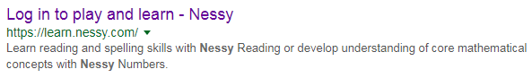
- Search for Nessy and click on this link.

- You may be asked to input the secret word, which is TABOOTRACTOR (all in capitals)
- Type in your child’s name and then click on it when it appears.
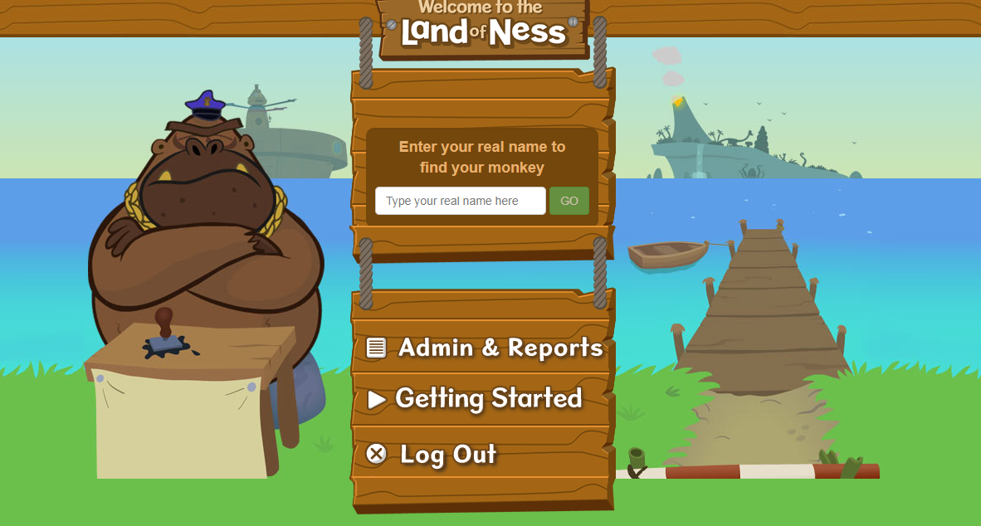
- Click on to Nessy Reading and Spelling.
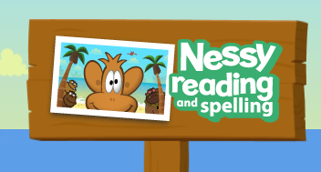

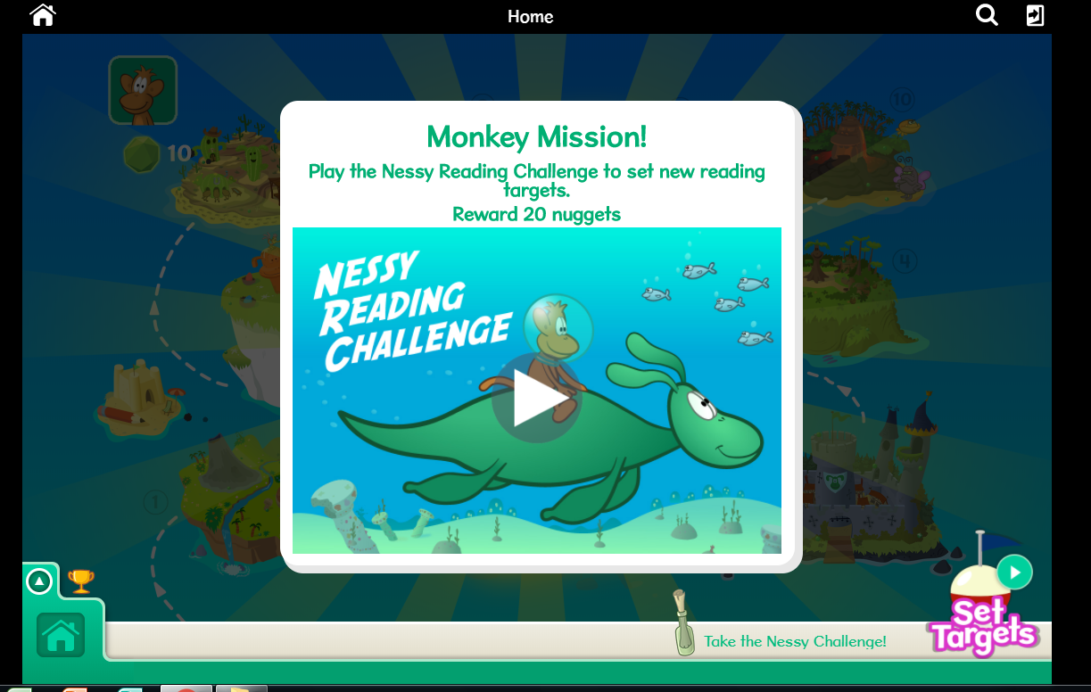
- You will then see a screen like the one below. The children then click on the screen as it prompts them.

Hopefully your child will enjoy this and the more they go on it, the better their spelling will become. There is no limit to how often they go on it. They will also be given time in school to access this.

Thanks for your continued support.

