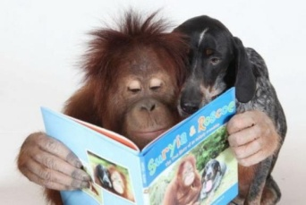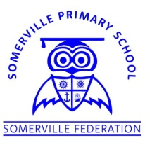**Somerville’s Reading Newsletter**

**Friday 7th February 2020**

**We are readers...**

Welcome back!

We want to create a world where everyone is reading their way to a better life. Research shows that reading for pleasure can promote better health and wellbeing, aids in building social connections and relationships with others and is associated with a range of factors to reduce stress and anxiety.

Mrs Fossett

**Books of the Week**

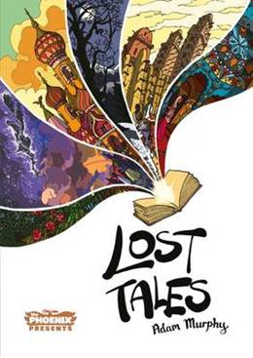

**Lost Tales**

Adam Murphy

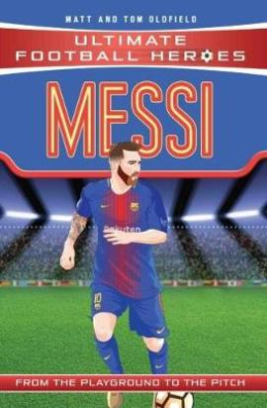

# Messi (Ultimate Football Heroes) - Collect them all!

## [Tom Oldfield](https://www.thebookpeople.co.uk/webapp/wcs/stores/servlet/browse_author_books?author=Tom+Oldfield)

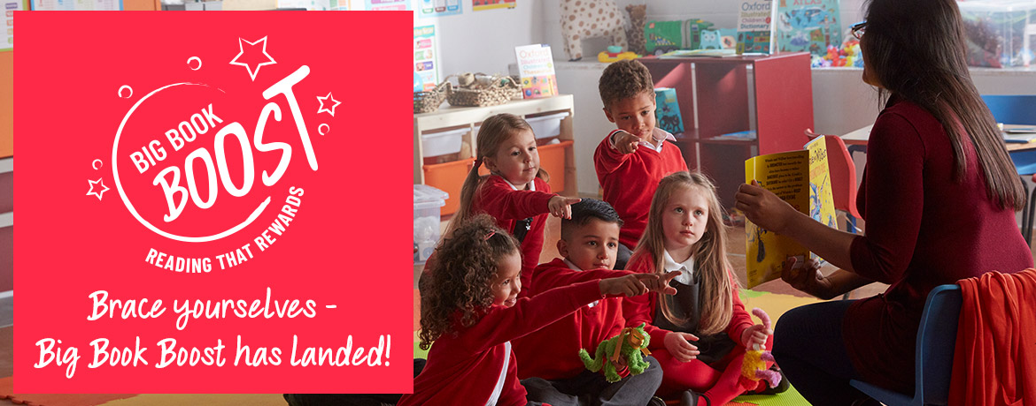**What is Big Book Boost?**

Big Book Boost is The Book People’s brand new fundraising scheme. Every time you place an order with **The Book People** over £10, they will donate £1 to our school for us to spend on books!

The Book People often sell a range of books with lots of offers on throughout the year.

[www.thebookpeople.co.uk](http://www.thebookpeople.co.uk)

**Class of the Week**

Percentage of children who read 3x or more at home

|  |  |  |
| --- | --- | --- |
| **Class** | **Last week** | **This week** |
| Badger | 31% | 37% |
| Bat | 15% | 33% |
| Fox | 22% | 4% |
| Hedgehog | 24% | 17% |
| Otter | 26% | 41% |
| Robin | 50% | 50% |
| Owl | 62% | 27% |
| Squirrel | 37% | 37% |
| Holly | 61% | 29% |
| Maple | 23% | 19% |
| Douglas Fir | 44% | 44% |
| Oak | 39% | 43% |
| Pine | 44% | 44% |
| Silver Birch | 44% | 34% |
| Willow | 42% | 32% |
| Cherry | **81%** | 74% |
| Elm | 70% | 85% |
| Sycamore | 52% | 41% |

**Well done Elm class!**

The more you read with your child at home, the better they will become at reading.

My favourite book is the Enchanted Wood: The Magic Faraway Tree by Enid Blyton because this was one of my very first books that I read as a series of books. It was bought for me by my two special Aunties, Pauline and Jean.

Mr Forber

**Somerville Favourites**

