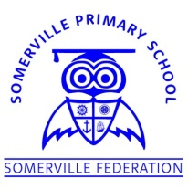**Somerville’s Reading Newsletter**

**Friday 24th January 2020**

**We are readers...**

**Books of the Week**

Welcome to our first edition of our weekly reading newsletter. I am excited to share with you what is happening in school for reading and some lovely books that you can read at home with your children.

Happy reading!

Mrs Fossett

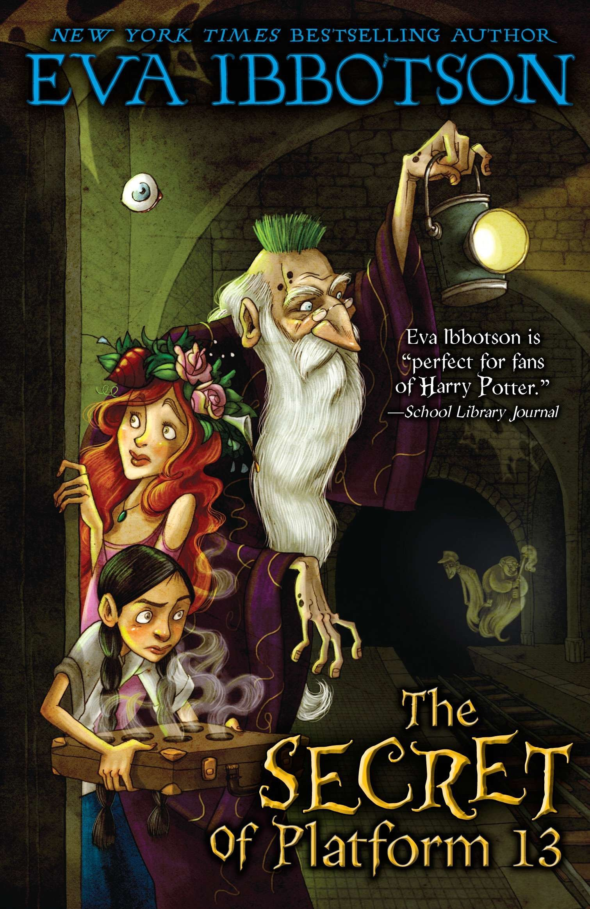

The Secret of Platform 13

Eva Ibbotson

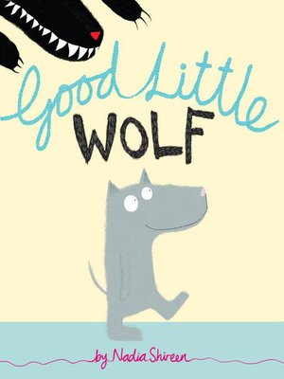

Good Little Wolf

Nadia Shireen

**Class of the Week**

Percentage of children who read 3x or more at home

|  |  |
| --- | --- |
| **Class** | **%** |
| Badger | **22%** |
| Bat | **7%** |
| Fox | **7%** |
| Hedgehog | **28%** |
| Otter | **37%** |
| Robin | **50%** |
| Owl | **35%** |
| Squirrel | **22%** |
| Holly | **41%** |
| Maple | **31%** |
| Douglas Fir | **22%** |
| Oak | **43%** |
| Pine | **34%** |
| Silver Birch | **34%** |
| Willow | **48%** |
| Cherry | **52%** |
| Elm | **59%** |
| Sycamore | **41%** |

**Well done Elm class!**

The more you read with your child at home, the better they will become at reading.

**Somerville Story Spine**

How many have you read?

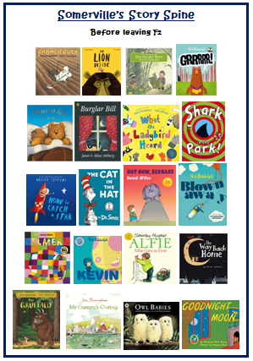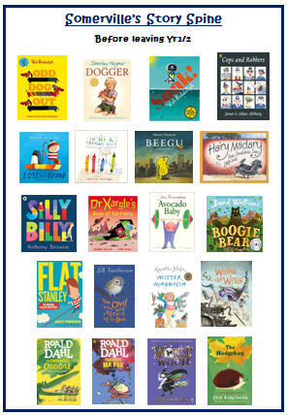

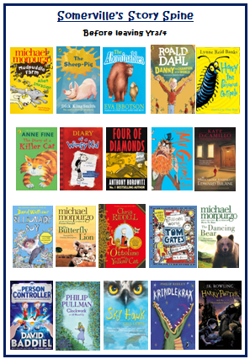 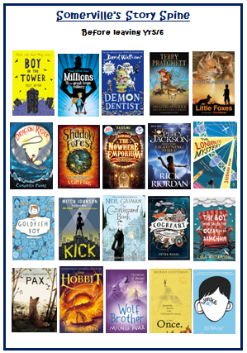

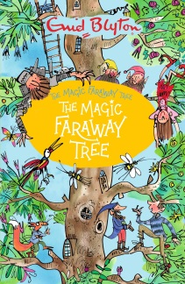

My favourite book is The Magic Faraway Tree by Enid Blyton because each chapter takes me to a new magical land where each adventure is different. Each land lets my imagination work wonders, picturing what it might be like from the author’s description.

Miss Dellius

**Somerville Favourites**