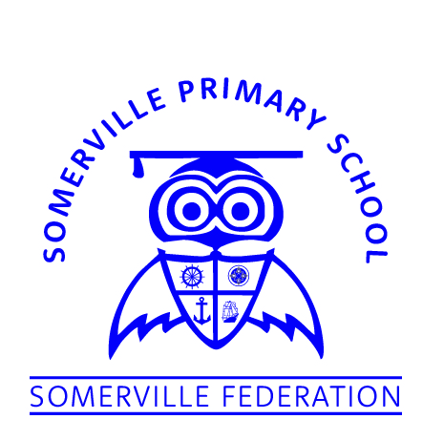

13th November 2019

Dear Parents and Carers

Re: School Swimming Lessons

Your child will be taking part in the schools swimming programme. Lessons will take place at Guinea Gap Swimming Baths from Monday 18th November 2019. Lessons will take place every afternoon for 2 weeks.

In order to comply with National and Local Authority health and safety guidelines I am writing to inform you of the appropriate swimwear that should be worn for the lessons.

Your child should either wear a one piece costume or swimming shorts or trunks that are an appropriate length. Please refer to the attached pictures for guidance.

Thank you for your support and I hope your child enjoys their swimming lessons.

Yours Faithfully,

Mr Forber
Executive Headteacher

CORRECT SWIMWEAR
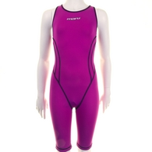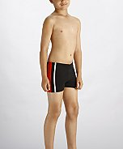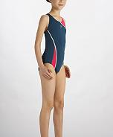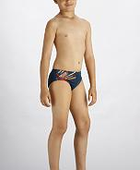

INCORRECT SWIMWEAR
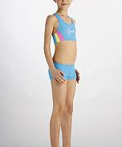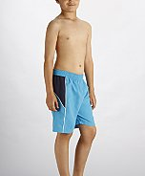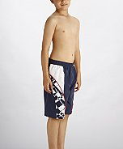

Swimming trunks should be mid-thigh and above the knee. If they fall on or below the knee, and/or have baggy pockets, the child will not be able to take part in the lessons. Swimming costume should be a one piece suit only or the child will not be able to take part in the lesson.

